**Detailed Business Specific Requirements:-**

**Theme**: Existing IT system for internal agencies of MoJS

**Applications**: "**WIMS expansion-WRIS**

**Use Cases:-** "Flood Inundation Mapping”-**FA-UC-02**

**Other linked Use Case :-** Flood prone area assessment (FPA)(FA-UC-03)& Flood plain Zoning(FA-UC-05)& other purposes like post damage assessment.

**Description**:-Remote sensing data already plays a significant role in water Resources management, but further, advancement in the technology promise to support sustainable water resource management and development in more comprehensive and holistic manner. Earth Observation Satellite (EOS)-04 or RISAT -1 A is follow on to RISAT -1 and launched in February 2022 based on the recommendation from planning Committee of space applications Management System (PC-SAMS),Subsequent to evaluation of its needs aspects by various Ministry/Dept. The EOS-04 is first of its kind mission that went through a series of deliberations with planning committee, of Space Applications Management systems (PC-SAMS) mechanism, wherein it intended utilization plan was endorsed by the user Ministries, and funding support was also provided by them, including launch cost. Ministry of Jal shakti (MoJS) is one of such agency. The Image acquired from RISA-1A at regular intervals are being used for various application in water resources.

**Reframe:** Remote sensing data has already made a significant impact on water resource management, and advancements in technology promise to enhance sustainable management and development in a more comprehensive and holistic manner. The Earth Observation Satellite (EOS)-04, also known as RISAT-1A, was launched in February 2022 as a follow-on to RISAT-1, following recommendations from the Planning Committee of the Space Applications Management System (PC-SAMS). This mission underwent extensive deliberations with the PC-SAMS, where its intended utilization plan received endorsement from user ministries, which also provided funding support, including the launch costs. The Ministry of Jal Shakti (MoJS) is one of the key agencies involved. The images acquired from RISAT-1A at regular intervals are being utilized for various applications in water resource management.

**Use case Of Description:**

**Use Case: Utilization of RISAT-1A Data for Water Resource Management**

**Actors:**

* Water Resource Manager
* Data Analyst
* Policy Maker
* Ministry of Jal Shakti (MoJS)
* Researcher
* General Public

**Description:**

This use case involves the application of data acquired from the RISAT-1A satellite to support sustainable water resource management and development. The data is used for monitoring, assessment, and planning purposes by various stakeholders.

**Pre conditions:**

* RISAT-1A satellite is operational and regularly acquiring images.
* Relevant data processing and analysis tools are available.
* Stakeholders have access to the satellite data.

**Post conditions:**

* Enhanced decision-making for water resource management.
* Improved planning and implementation of water-related projects.
* Increased public awareness and engagement in water resource issues.

**Main Flow:**

1. **Data Acquisition:** The Water Resource Manager schedules the acquisition of satellite images from RISAT-1A.
2. **Data Processing:** The Data Analyst processes the acquired images to extract relevant information, such as water body extents, soil moisture levels, and land use changes.
3. **Data Analysis:** The processed data is analyzed to assess water availability, quality, and usage patterns.
4. **Reporting:** The Data Analyst generates reports based on the analysis, highlighting key findings and recommendations.
5. **Policy Development:** The Policy Maker uses the reports to inform policy decisions and develop strategies for sustainable water resource management.
6. **Public Engagement:** The Ministry of Jal Shakti (MoJS) disseminates information to the general public, raising awareness about water resource management and encouraging community involvement.
7. **Research and Development:** Researchers utilize the data for further studies on water resource management and to develop innovative solutions.

**Alternative Flows:**

* If data acquisition fails, the Water Resource Manager will reschedule the acquisition or seek alternative data sources.
* If the analysis reveals critical issues, the Policy Maker may convene an emergency meeting to address the situation.

**Use Case Benefits:**

* Facilitates informed decision-making through timely access to satellite data.
* Enhances the ability to monitor and manage water resources effectively.
* Promotes collaboration among various stakeholders in water resource management.

This use case highlights the importance of utilizing RISAT-1A satellite data to support sustainable water resource management, enabling stakeholders to make informed decisions and engage the public in water-related issues.

**Summary:** The use case for the utilization of RISAT-1A data in water resource management focuses on leveraging satellite imagery to enhance decision-making and planning for sustainable water management. Key actors, including water resource managers, data analysts, policy makers, the Ministry of Jal Shakti (MoJS), researchers, and the general public, collaborate to acquire, process, and analyze data from the RISAT-1A satellite. This process involves monitoring water availability, quality, and usage patterns, generating insightful reports, and informing policy development. The initiative aims to raise public awareness and encourage community involvement in water resource issues while promoting effective collaboration among stakeholders. Ultimately, this use case underscores the critical role of satellite data in facilitating informed decisions and improving the management of water resources.

**Figure 001_Intro_Usecase_PlantUML**

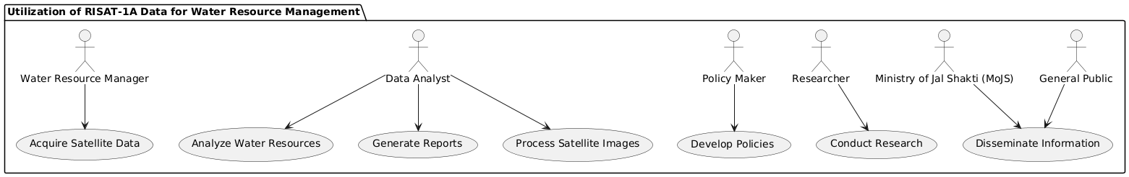

**Code For Figure 001_Intro_Usecase_PlantUML**

@startuml

package "Utilization of RISAT-1A Data for Water Resource Management" {

actor "Water Resource Manager" as WRM

actor "Data Analyst" as DA

actor "Policy Maker" as PM

actor "Ministry of Jal Shakti (MoJS)" as MoJS

actor "Researcher" as R

actor "General Public" as GP

usecase "Acquire Satellite Data" as UCA1

usecase "Process Satellite Images" as UCA2

usecase "Analyze Water Resources" as UCA3

usecase "Generate Reports" as UCA4

usecase "Develop Policies" as UCA5

usecase "Disseminate Information" as UCA6

usecase "Conduct Research" as UCA7

WRM --> UCA1

DA --> UCA2

DA --> UCA3

DA --> UCA4

PM --> UCA5

MoJS --> UCA6

R --> UCA7

GP --> UCA6

}

@enduml

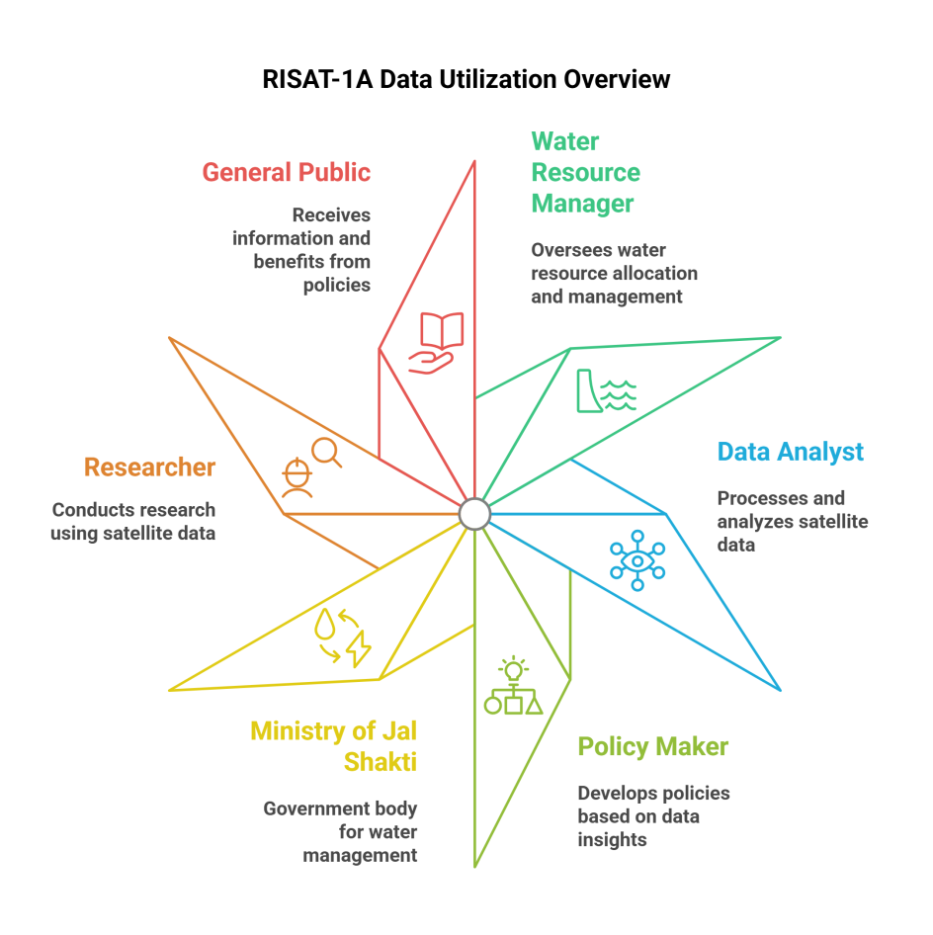**Figure 001_Intro_UsecaseFlow_NapkinAI**

**Figure 001_Intro_FlowChart_PlantUML**

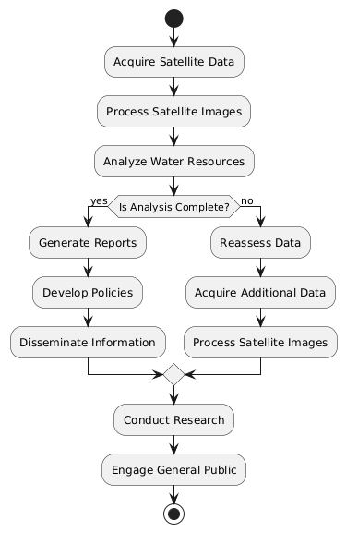

**Code For Figure 001_Intro_FlowChart_PlantUML**

@startuml

start

:Acquire Satellite Data;

:Process Satellite Images;

:Analyze Water Resources;

if (Is Analysis Complete?) then (yes)

:Generate Reports;

:Develop Policies;

:Disseminate Information;

else (no)

:Reassess Data;

:Acquire Additional Data;

:Process Satellite Images;

endif

:Conduct Research;

:Engage General Public;

stop

@enduml

**Used By (End Users):-** Planners, Decision makers, administrator, academicians, SDMA and NDMA, Insurers and General public.

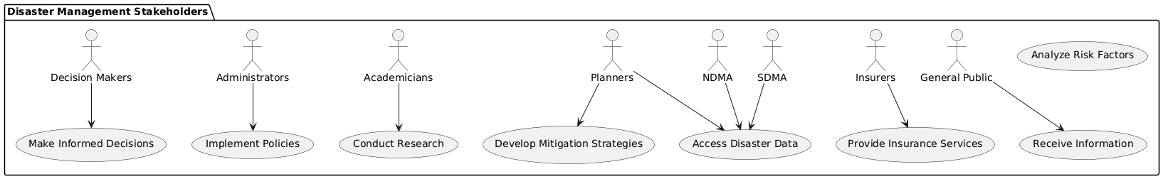**Figure 002_EndUsers_Usecase_PlantUML**

**Code For Figure 002_EndUsers_Usecase_PlantUML**

@startuml

package "Disaster Management Stakeholders" {

actor "Planners" as P

actor "Decision Makers" as DM

actor "Administrators" as A

actor "Academicians" as AC

actor "SDMA" as SD

actor "NDMA" as ND

actor "Insurers" as I

actor "General Public" as GP

usecase "Access Disaster Data" as UCA1

usecase "Analyze Risk Factors" as UCA2

usecase "Develop Mitigation Strategies" as UCA3

usecase "Make Informed Decisions" as UCA4

usecase "Implement Policies" as UCA5

usecase "Conduct Research" as UCA6

usecase "Provide Insurance Services" as UCA7

usecase "Receive Information" as UCA8

P --> UCA1

P --> UCA3

DM --> UCA4

A --> UCA5

AC --> UCA6

SD --> UCA1

ND --> UCA1

I --> UCA7

GP --> UCA8

}

@enduml

**Figure 002_EndUsers_UsecaseFlow_NapkinAI**

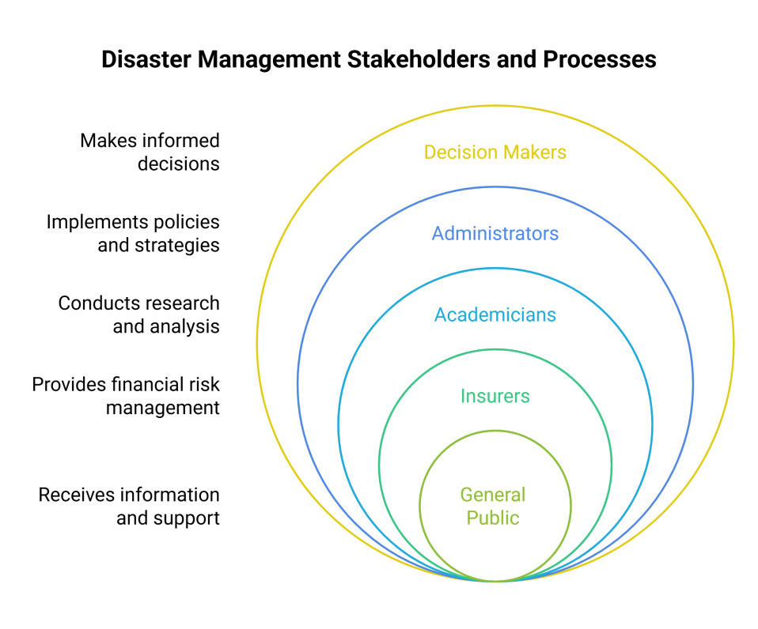

**Figure 002_EndUsers_FlowChart_DiagramGPT_With MermaidCode**

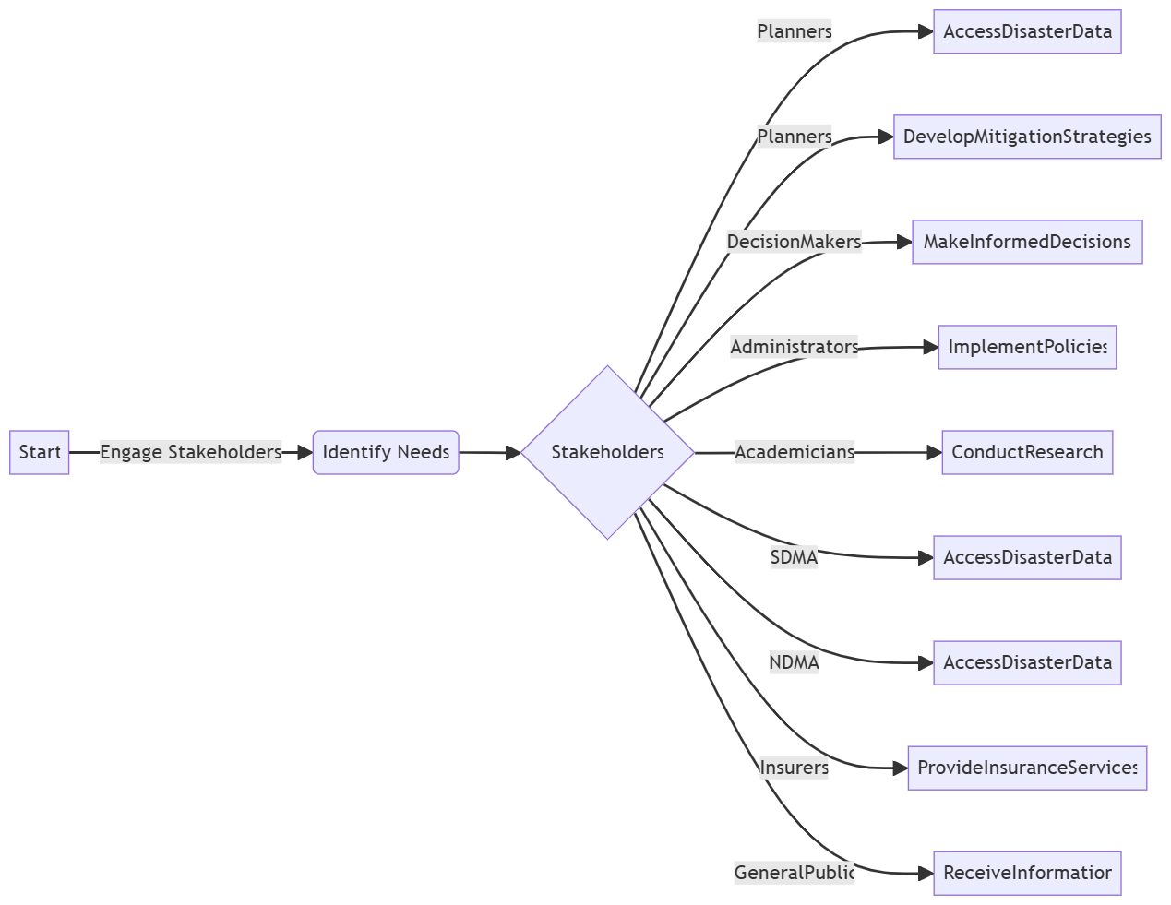

**Code For Figure 002_EndUsers_FlowChart_DiagramGPT_With MermaidCode**

flowchart LR

A[Start] --Engage Stakeholders--> B(Identify Needs)

B --> C{Stakeholders}

C -- Planners --> D[AccessDisasterData]

C -- Planners --> E[DevelopMitigationStrategies]

C -- DecisionMakers --> F[MakeInformedDecisions]

C -- Administrators --> G[ImplementPolicies]

C -- Academicians --> H[ConductResearch]

C -- SDMA --> I[AccessDisasterData]

C -- NDMA --> J[AccessDisasterData]

C -- Insurers --> K[ProvideInsuranceServices]

C -- GeneralPublic --> L[ReceiveInformation]

**Priority**:- **High Priority :** This use case is important for post disaster management, assessment, deployment of disaster response teams, planning of mitigation measures and as an input to calibrate and validate models on flood inundation forecasting.

**Reframe:** This use case is crucial for post-disaster management, enabling effective assessment, deployment of disaster response teams, planning of mitigation measures, and serving as a key input for calibrating and validating flood inundation forecasting models.

**Use case Of Priority:**

**Use Case: Post-Disaster Management and Response Planning**

**Actors:**

* Disaster Management Coordinator
* Data Analyst
* Disaster Response Team
* Modeling Specialist
* Stakeholders (Government Agencies, NGOs)

**Description:**

This use case involves the systematic assessment and management of disaster response efforts following an event, utilizing data to inform decision-making, deploy response teams, plan mitigation measures, and calibrate flood inundation forecasting models.

**Preconditions:**

* A disaster event has occurred, necessitating immediate response and assessment.
* Relevant data from satellite imagery, ground reports, and historical records is available.
* Communication channels among stakeholders are established.

**Post conditions:**

* Effective deployment of disaster response teams.
* Comprehensive assessment reports generated for stakeholders.
* Mitigation measures planned and implemented.
* Flood inundation forecasting models calibrated and validated.

**Main Flow:**

1. **Initiate Assessment**: The disaster management coordinator initiates the assessment process following a disaster event.
2. **Collect Data**: The data analyst gathers relevant data, including satellite imagery, ground reports, and historical data.
3. **Analyze Data**: The data analyst processes and analyzes the collected data to identify affected areas and assess the extent of damage.
4. **Deploy Response Teams**: Based on the assessment, the disaster response team is deployed to the most affected areas.
5. **Plan Mitigation Measures**: The disaster management coordinator collaborates with stakeholders to plan and implement mitigation measures to reduce future risks.
6. **Calibrate Models**: The modeling specialist uses the assessment data to calibrate and validate flood inundation forecasting models.
7. **Generate Reports**: The data analyst prepares comprehensive reports detailing the assessment findings, response actions, and recommendations for stakeholders.
8. **Feedback Loop**: Stakeholders provide feedback on the reports and response actions, which is used to improve future disaster management strategies.

**Alternative Flows:**

* If data collection is incomplete, the data analyst will seek additional information from local authorities or other sources.
* If the response teams encounter obstacles, the disaster management coordinator will adjust deployment strategies accordingly.

**Use Case Benefits:**

* Enhances the effectiveness of disaster response efforts through informed decision-making.
* Facilitates collaboration among various stakeholders in managing disaster impacts.
* Improves future disaster preparedness by calibrating forecasting models based on real-time data.

This use case emphasizes the importance of a structured approach to post-disaster management, leveraging data to enhance response efforts and inform future planning.

**Summary:** The use case for post-disaster management and response planning focuses on the systematic assessment and management of disaster response efforts following an event, involving key actors such as disaster management coordinators, data analysts, disaster response teams, modeling specialists, and stakeholders. It begins with the initiation of an assessment process, where relevant data—including satellite imagery and ground reports—is collected and analyzed to identify affected areas and assess damage. Based on this analysis, disaster response teams are deployed, and mitigation measures are collaboratively planned with stakeholders. Additionally, the collected data is used to calibrate and validate flood inundation forecasting models, while comprehensive reports detailing the assessment findings and recommendations are generated for stakeholders. This structured approach enhances the effectiveness of disaster response efforts, promotes collaboration among various entities, and improves future disaster preparedness through informed decision-making.

**Figure 003_Priority_Usecase_PlantUML**

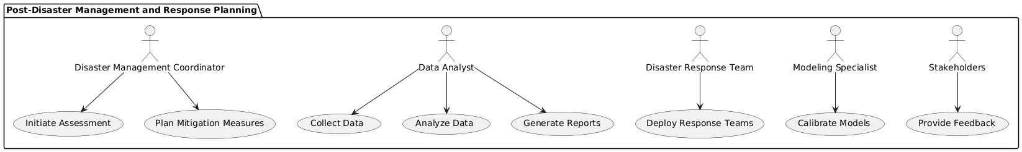

**Code For Figure 003_Priority_Usecase_PlantUML**

@startuml

package "Post-Disaster Management and Response Planning" {

actor "Disaster Management Coordinator" as DMC

actor "Data Analyst" as DA

actor "Disaster Response Team" as DRT

actor "Modeling Specialist" as MS

actor "Stakeholders" as S

usecase "Initiate Assessment" as UCA1

usecase "Collect Data" as UCA2

usecase "Analyze Data" as UCA3

usecase "Deploy Response Teams" as UCA4

usecase "Plan Mitigation Measures" as UCA5

usecase "Calibrate Models" as UCA6

usecase "Generate Reports" as UCA7

usecase "Provide Feedback" as UCA8

DMC --> UCA1

DA --> UCA2

DA --> UCA3

DRT --> UCA4

DMC --> UCA5

MS --> UCA6

DA --> UCA7

S --> UCA8

}

@enduml

**Figure 003_Priority_ UsecaseFlow_NapkinAI**

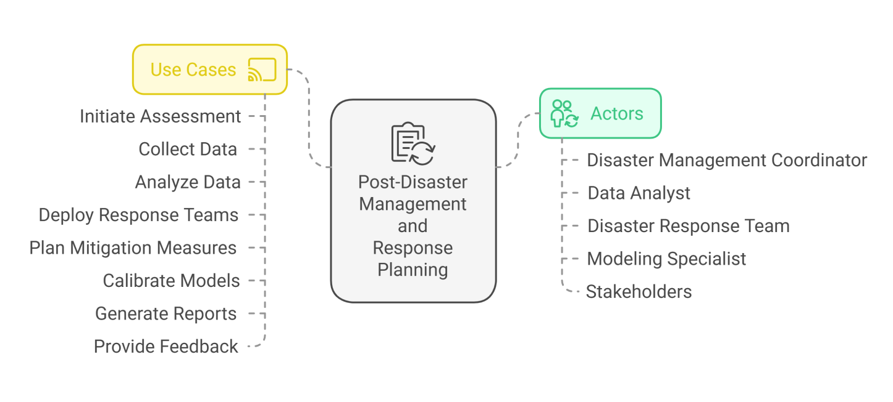

**Figure 003_Priority_FlowChart_DiagramGPT_With MermaidCode**

**Code For Figure 003_Priority_FlowChart_DiagramGPT_With MermaidCode**

flowchart TD

DMC["Disaster Management Coordinator"] --> UCA1["Initiate Assessment"]

DA["Data Analyst"] --> UCA2["Collect Data"]

DA --> UCA3["Analyze Data"]

DRT["Disaster Response Team"] --> UCA4["Deploy Response Teams"]

DMC --> UCA5["Plan Mitigation Measures"]

MS["Modeling Specialist"] --> UCA6["Calibrate Models"]

DA --> UCA7["Generate Reports"]

S["Stakeholders"] --> UCA8["Provide Feedback"]

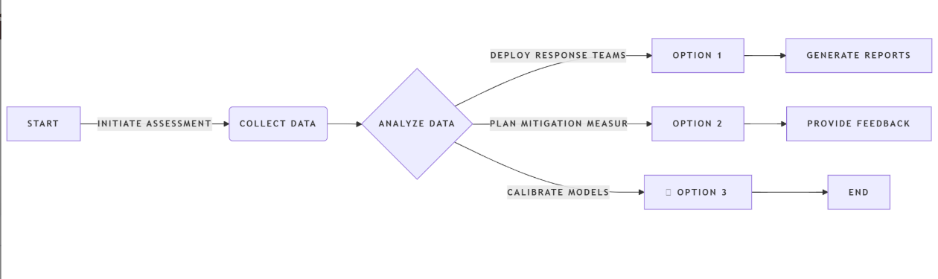**Figure 003_Priority_FlowChart_NoteGPT_With MermaidCode**

**Code For Figure 003_Priority_FlowChart_NoteGPT_With MermaidCode**

flowchart LR

A[Start] --Initiate Assessment--> B(Collect Data)

B --> C{Analyze Data}

C --Deploy Response Teams--> D[Option 1]

C --Plan Mitigation Measures--> E[Option 2]

C --Calibrate Models--> F[fa:fa-car Option 3]

D --> G[Generate Reports]

E --> H[Provide Feedback]

F --> I[End]

**Phase:-** **Phase**  **2:** DSS Development of WARIMS

**Governance Need (Business Problem):-**

RISAT-1A acquires large spatial datasets at regular interval for PAN India for which high computational resources for continuous fetching of satellite data, archiving and processing for intended purpose. This further requires a visualization platform for GIS query based decision support system (DSS) for utilization among all stakeholders**.**

**Reframe:** RISAT-1A collects extensive spatial datasets at regular intervals across PAN India, necessitating significant computational resources for the continuous retrieval, archiving, and processing of satellite data for its intended applications. Additionally, a visualization platform is required to support a GIS-based decision support system (DSS) that facilitates effective utilization among all stakeholders.

**Use case Of Govt. Need:**

**Use Case: Utilization of RISAT-1A Satellite Data for Decision Support**

**Actors:**

* Satellite Data Analyst
* Data Engineer
* GIS Specialist
* Decision Makers (Stakeholders)
* System Administrator

**Description:**

This use case involves the continuous acquisition, processing, and visualization of satellite data from RISAT-1A to support decision-making processes among various stakeholders across PAN India.

**Preconditions:**

* RISAT-1A satellite is operational and collecting data.
* Sufficient computational resources are available for data processing.
* A GIS platform is in place for data visualization.

**Post conditions:**

* Processed satellite data is available for analysis and decision-making.
* Stakeholders can access visualized data through the GIS platform.

**Main Flow:**

1. **Data Acquisition:** The satellite data analyst initiates the process by scheduling regular data acquisition from RISAT-1A.
2. **Data Retrieval:** The data engineer retrieves the satellite data and ensures it is archived properly for future use.
3. **Data Processing:** The data engineer processes the acquired datasets to prepare them for analysis, ensuring they meet the intended purpose.
4. **Data Visualization:** The GIS specialist utilizes the processed data to create visual representations on the GIS platform.
5. **Decision Support:** Decision makers access the GIS platform to query the visualized data, enabling informed decision-making based on the satellite information.
6. **Feedback Loop:** Stakeholders provide feedback on the data and visualizations, which is used to refine data processing and visualization methods.

**Alternative Flows:**

* If data retrieval fails, the data engineer will troubleshoot the issue and attempt to re-establish the connection to the satellite data source.
* If the GIS platform encounters issues, the system administrator will resolve technical problems to ensure accessibility for stakeholders.

**Use Case Benefits:**

* Enables timely access to critical satellite data for various applications, including disaster management, agriculture monitoring, and urban planning.
* Facilitates informed decision-making through effective visualization of complex datasets.
* Promotes collaboration among stakeholders by providing a shared platform for data access and analysis.

This use case highlights the importance of utilizing RISAT-1A satellite data effectively to support decision-making processes among stakeholders through robust data acquisition, processing, and visualization methods.

**Summary:** The use case for the utilization of RISAT-1A satellite data focuses on the continuous acquisition, processing, and visualization of extensive spatial datasets to support decision-making among various stakeholders across PAN India. It involves key actors such as satellite data analysts, data engineers, GIS specialists, decision makers, and system administrators, who collaboratively ensure that satellite data is regularly retrieved, archived, and processed for specific applications. The processed data is then visualized on a GIS platform, allowing decision makers to access and query the information for informed decision-making in areas such as disaster management, agriculture monitoring, and urban planning. This use case emphasizes the importance of effective data utilization and visualization in facilitating timely access to critical information, promoting collaboration among stakeholders, and enhancing overall decision support capabilities.

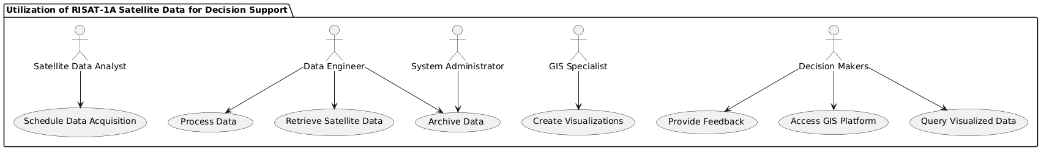**Figure 004_Govt. Need_Usecase_PlantUML**

**Code For Figure 004_Govt. Need_Usecase_PlantUML**

@startuml

package "Utilization of RISAT-1A Satellite Data for Decision Support" {

actor "Satellite Data Analyst" as SDA

actor "Data Engineer" as DE

actor "GIS Specialist" as GS

actor "Decision Makers" as DM

actor "System Administrator" as SA

usecase "Schedule Data Acquisition" as UCA1

usecase "Retrieve Satellite Data" as UCA2

usecase "Archive Data" as UCA3

usecase "Process Data" as UCA4

usecase "Create Visualizations" as UCA5

usecase "Access GIS Platform" as UCA6

usecase "Query Visualized Data" as UCA7

usecase "Provide Feedback" as UCA8

SDA --> UCA1

DE --> UCA2

DE --> UCA3

DE --> UCA4

GS --> UCA5

DM --> UCA6

DM --> UCA7

DM --> UCA8

SA --> UCA3

}

@enduml

**Figure 004_Govt. Need_UsecaseFlow_NapkinAI**

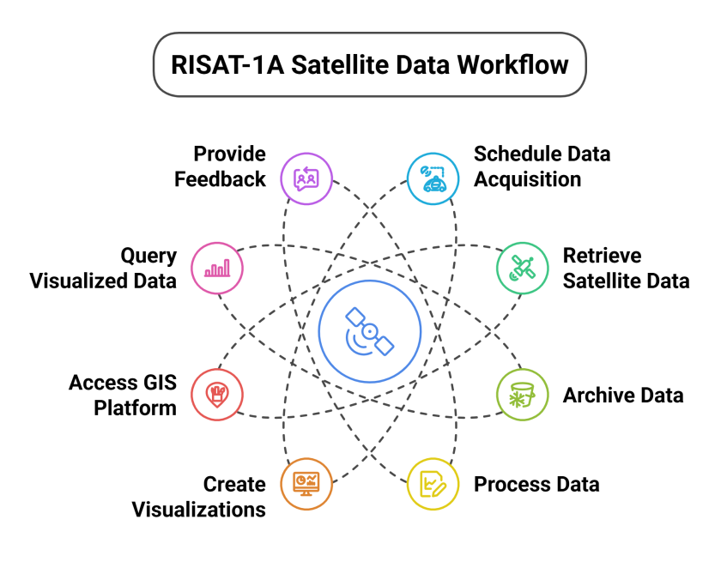

**Figure Of NoteGPT_FlowChart**

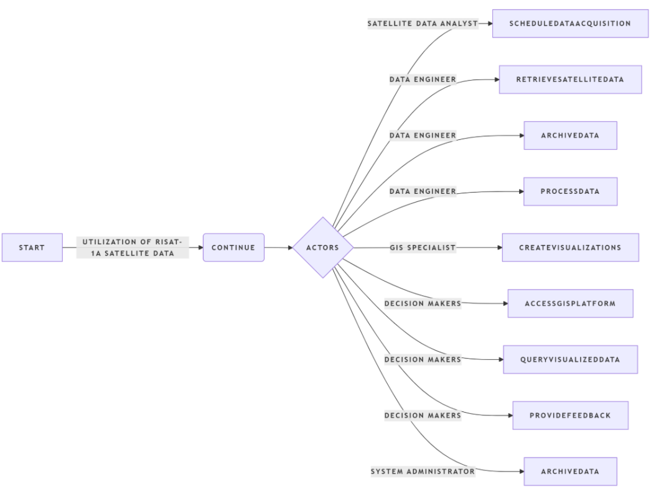

**Figure 004_Govt. Need_FlowChart_MermaidChart_With MermaidCode**

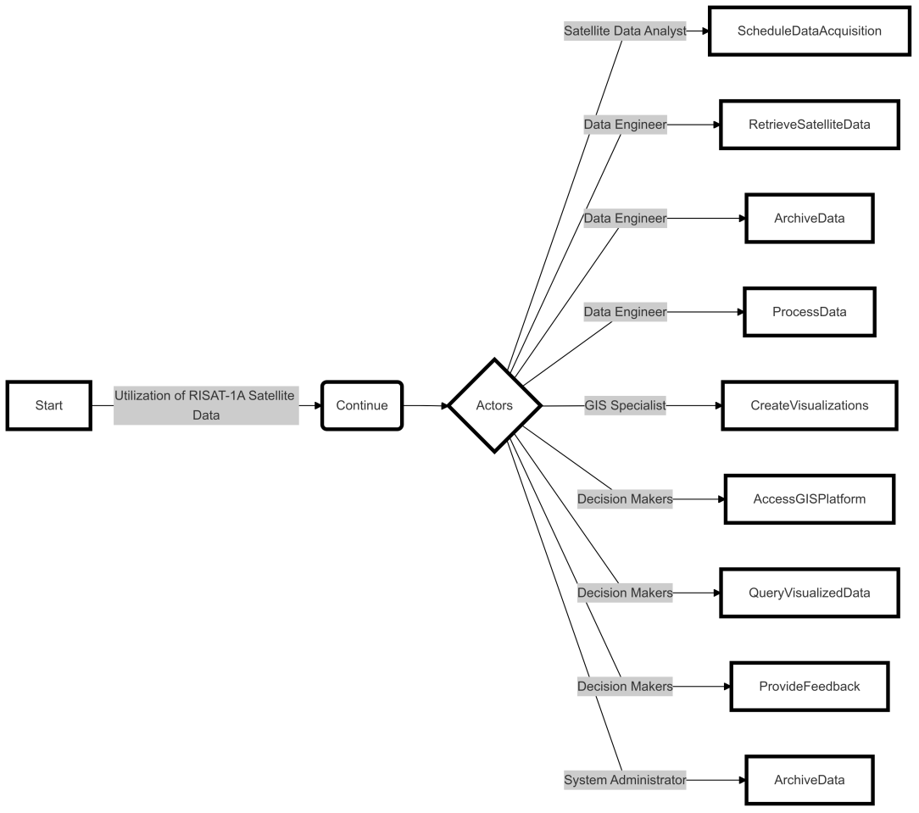

**Code For Figure 004_Govt. Need_FlowChart_NoteGPT_With MermaidCode**

---

config:

  layout: dagre

  look: classic

---

**flowchart** LR

    A["Start"] -- "Utilization of RISAT-1A Satellite Data" **-->** B("Continue")

    B **-->** C{"Actors"}

    C **--** Satellite Data Analyst **-->** D["ScheduleDataAcquisition"]

    C **--** Data Engineer **-->** E["RetrieveSatelliteData"] **&** F["ArchiveData"] **&** G["ProcessData"]

    C **--** GIS Specialist **-->** H["CreateVisualizations"]

    C **--** Decision Makers **-->** I["AccessGISPlatform"] **&** J["QueryVisualizedData"] **&** K["ProvideFeedback"]

    C **--** System Administrator **-->** L["ArchiveData"]

    style A stroke-width:4px,stroke-dasharray: 0

    style B stroke:#000000,stroke-width:4px,stroke-dasharray: 0

    style C stroke-width:4px,stroke-dasharray: 0

    style D stroke-width:4px,stroke-dasharray: 0

    style E stroke-width:4px,stroke-dasharray: 0

    style F stroke-width:4px,stroke-dasharray: 0

    style G stroke-width:4px,stroke-dasharray: 0

    style H stroke-width:4px,stroke-dasharray: 0

    style I stroke-width:4px,stroke-dasharray: 0

    style J stroke-width:4px,stroke-dasharray: 0

    style K stroke-width:4px,stroke-dasharray: 0

    style L stroke-width:4px,stroke-dasharray: 0

**Output:-** Estimated Spatial Flood Extent Near real-time flood inundation maps along with reports

**Expected Outcome:-** Post-disaster management, assessment, deployment of disaster response teams, planning of mitigation measures and as an input to calibrate and validate models on flood inundation forecasting.

**Visualization:-**

**1. Map of inundated areas corresponding to each flood event with date**

* **Political boundary**
* State
* District
* Town/village/ Panchayat boundary
* Boundaries of Assembly and Parliamentary constituencies
* **Hydrological Boundary**
* Basin,
* Sub-Basin
* River
* Base Layers
* **All types of base layers as available should be displayed such as:-**
* Infrastructure
* Water Projects
* Population
* Places
* Crop Area
* LULC
* Embankments
* Built-up area

**Figure 005_Visulisation_SequDiag_PlantUML**

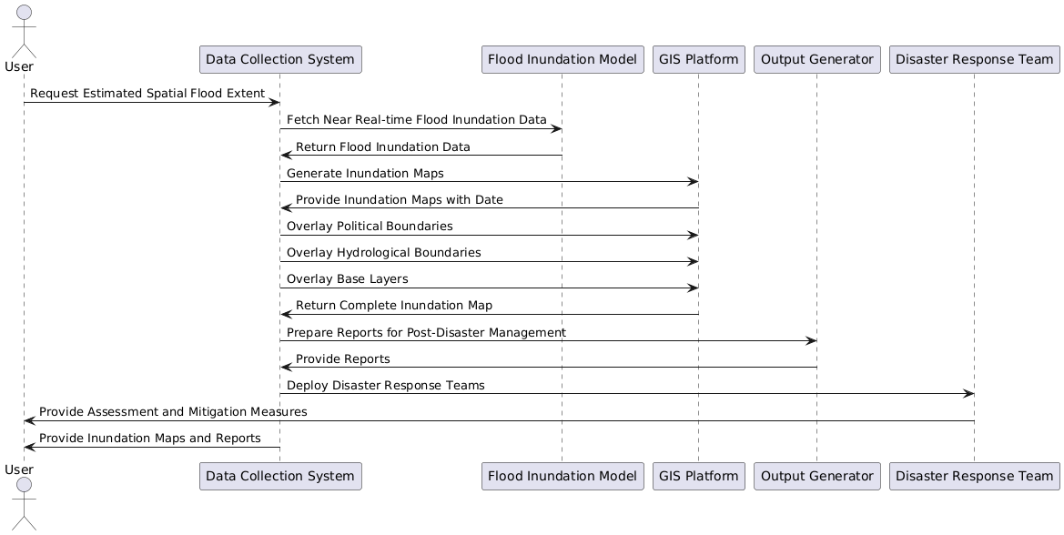

**Code For Figure 005_Visulisation_SequDiag_PlantUML**

@startuml

actor "User " as U

participant "Data Collection System" as DCS

participant "Flood Inundation Model" as FIM

participant "GIS Platform" as GIS

participant "Output Generator" as OG

participant "Disaster Response Team" as DRT

U -> DCS: Request Estimated Spatial Flood Extent

DCS -> FIM: Fetch Near Real-time Flood Inundation Data

FIM -> DCS: Return Flood Inundation Data

DCS -> GIS: Generate Inundation Maps

GIS -> DCS: Provide Inundation Maps with Date

DCS -> GIS: Overlay Political Boundaries

DCS -> GIS: Overlay Hydrological Boundaries

DCS -> GIS: Overlay Base Layers

GIS -> DCS: Return Complete Inundation Map

DCS -> OG: Prepare Reports for Post-Disaster Management

OG -> DCS: Provide Reports

DCS -> DRT: Deploy Disaster Response Teams

DRT -> U: Provide Assessment and Mitigation Measures

DCS -> U: Provide Inundation Maps and Reports

@enduml

**User Selection:-** The default screen will appear as a terrain map of India. By zooming, the required state, district, river, or inundated area can be searched. There will be a “Search” button also to facilitate searching for a particular district or river by name. When user clicks on an inundated area, the table mentioned below will pop up on screen with the following information:

1. Name of river basin
2. Name of river
3. Name of State/District
4. No. of villages/towns affected
5. Population affected
6. Length of road/railway line affected
7. No. and type of houses and other infrastructure affected
8. No. and type of critical structures (hospitals, fire stations, power plants and sub-stations, water supply and sewerage treatment plants, structures of historical and strategic importance etc.) affected, if any
9. Crop area damaged and estimated value of loss in Rs Lakhs
10. Dates of flooding with time series of images (historical spatial estimated flood extent)
11. Estimated Damage

**Figure 006_User Selection_SequDiag_PlantUML**

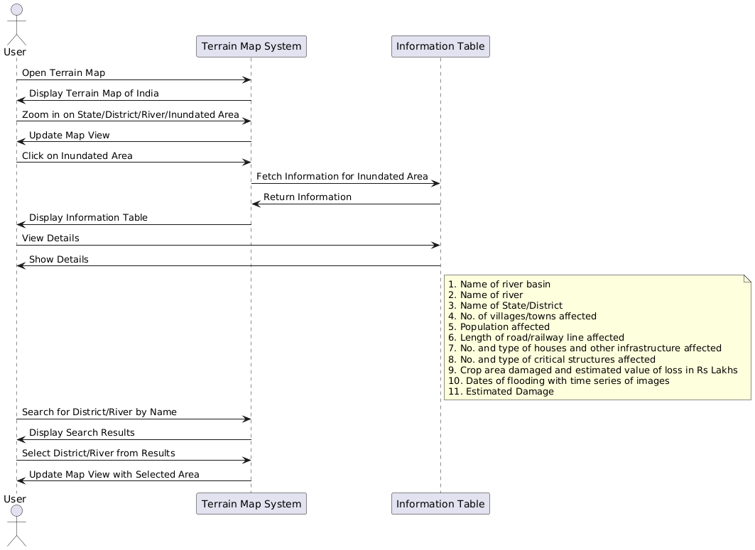

**Code For Figure 006_User Selection_SequDiag_PlantUML**

@startuml

actor User

participant "Terrain Map System" as System

participant "Information Table" as Table

User -> System: Open Terrain Map

System -> User: Display Terrain Map of India

User -> System: Zoom in on State/District/River/Inundated Area

System -> User: Update Map View

User -> System: Click on Inundated Area

System -> Table: Fetch Information for Inundated Area

Table -> System: Return Information

System -> User: Display Information Table

User -> Table: View Details

Table -> User: Show Details

note right of Table

1. Name of river basin

2. Name of river

3. Name of State/District

4. No. of villages/towns affected

5. Population affected

6. Length of road/railway line affected

7. No. and type of houses and other infrastructure affected

8. No. and type of critical structures affected

9. Crop area damaged and estimated value of loss in Rs Lakhs

10. Dates of flooding with time series of images

11. Estimated Damage

end note

User -> System: Search for District/River by Name

System -> User: Display Search Results

User -> System: Select District/River from Results

System -> User: Update Map View with Selected Area

@enduml

**Frequency of Up-dation:-** As soon as RISAT-1A data is acquired (near real time)

**Measure of Success:-** Based on feedback of stakeholders

**Input Data Required:-**

|  |  |  |
| --- | --- | --- |
| **Data** | **Unit** | **Type** |
| SAR data | Satellite Imagery | ISRO/RISAT-1A / NWIC |
| Population density map with village/town as unit | Decimal Number | Census / NWIC |
| LULC map with special reference to area under crops | Map | NRSC/ Satellite Image / NWIC |
| Map layer showing railway network | Map | NRSC/ Satellite Image / NWIC |
| Map layer showing road network | Map | NRSC/ Satellite Image / NWIC |
| Map layer showing important structures like hospitals, fire stations, power plants and substations for power supply, water supply and sewerage treatment plants, police stations, structures of historical and strategic importance, nearest flood shelter etc | Map | Sol/ NRSC/ High resolution Satellite Images / NWIC |
| Length of road/railway line affected | Decimal number | Transportation network layer prepared in-house / NWIC |

**Process:**

**Algorithm/Tools:-**

**Step 1:** Fetch all base layers as listed above,

**Step 2:** **Fetch recently available RISAT-1A satellite data**

**Step 3:** Processing the SAR data (RISAT-1A) preparation of water masks from satellite data. The steps are as follows:

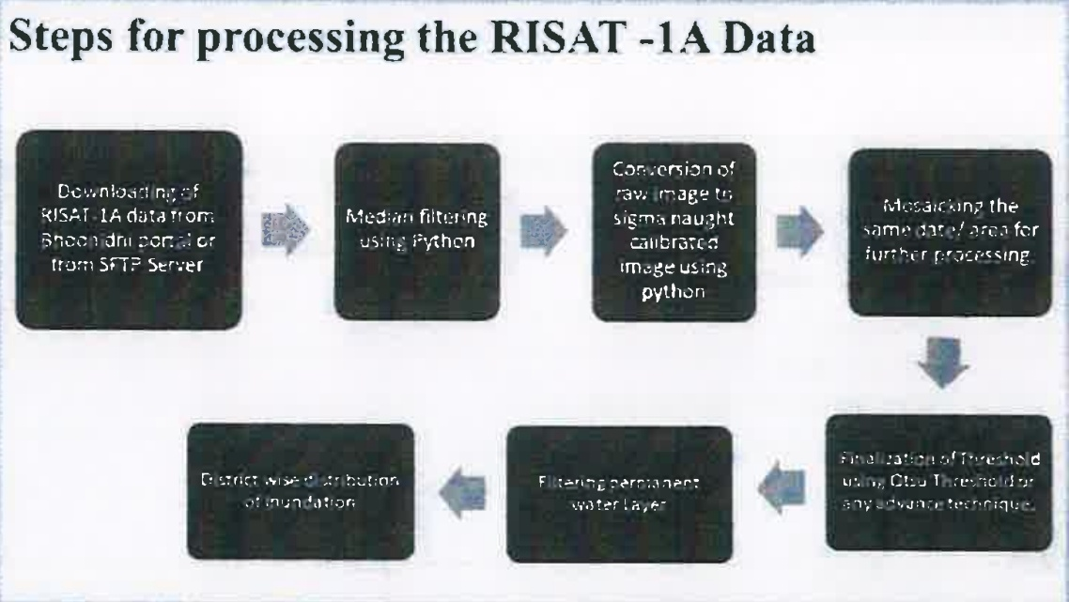

**Step 4:** Superimpose the water masks on the natural water bodies prepared in Step-1 and derive the flood-inundated areas

**Step-5:** Superimpose the flood inundated maps on available village/town/city maps, transportation network, population density map, crop area map and other infrastructure maps and find out no. of village/towns affected, number of people affected, length of road/railway line affected, crop affected, no. of other important/ critical infrastructure affected etc.

**Step 6:** Estimate the damages for the chosen administrative unit as applicable.

**Step 7:** Outputs displayed on a GIS platform.

**Step 8:** Chart of estimated flood extent at selected location pixels.

**Step 9:** Provide data download option in multiple formats i.e. .pdf., .csv, xls, .png

**Figure 007_Tools/Step_SequDiag_PlantUML**

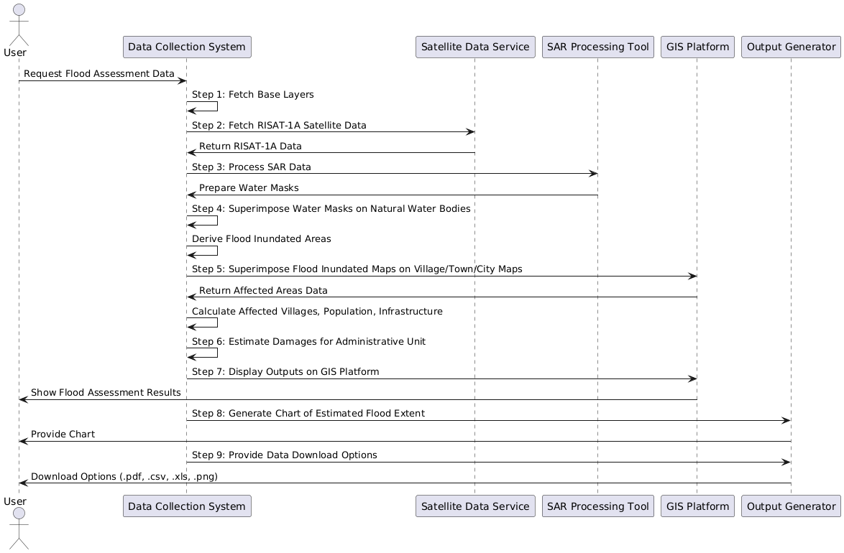

**Code For Figure 007_Tools/Step_SequDiag_PlantUML**

@startuml

actor "User " as U

participant "Data Collection System" as DCS

participant "Satellite Data Service" as SDS

participant "SAR Processing Tool" as SPT

participant "GIS Platform" as GIS

participant "Output Generator" as OG

U -> DCS: Request Flood Assessment Data

DCS -> DCS: Step 1: Fetch Base Layers

DCS -> SDS: Step 2: Fetch RISAT-1A Satellite Data

SDS -> DCS: Return RISAT-1A Data

DCS -> SPT: Step 3: Process SAR Data

SPT -> DCS: Prepare Water Masks

DCS -> DCS: Step 4: Superimpose Water Masks on Natural Water Bodies

DCS -> DCS: Derive Flood Inundated Areas

DCS -> GIS: Step 5: Superimpose Flood Inundated Maps on Village/Town/City Maps

GIS -> DCS: Return Affected Areas Data

DCS -> DCS: Calculate Affected Villages, Population, Infrastructure

DCS -> DCS: Step 6: Estimate Damages for Administrative Unit

DCS -> GIS: Step 7: Display Outputs on GIS Platform

GIS -> U: Show Flood Assessment Results

DCS -> OG: Step 8: Generate Chart of Estimated Flood Extent

OG -> U: Provide Chart

DCS -> OG: Step 9: Provide Data Download Options

OG -> U: Download Options (.pdf, .csv, .xls, .png)

@enduml

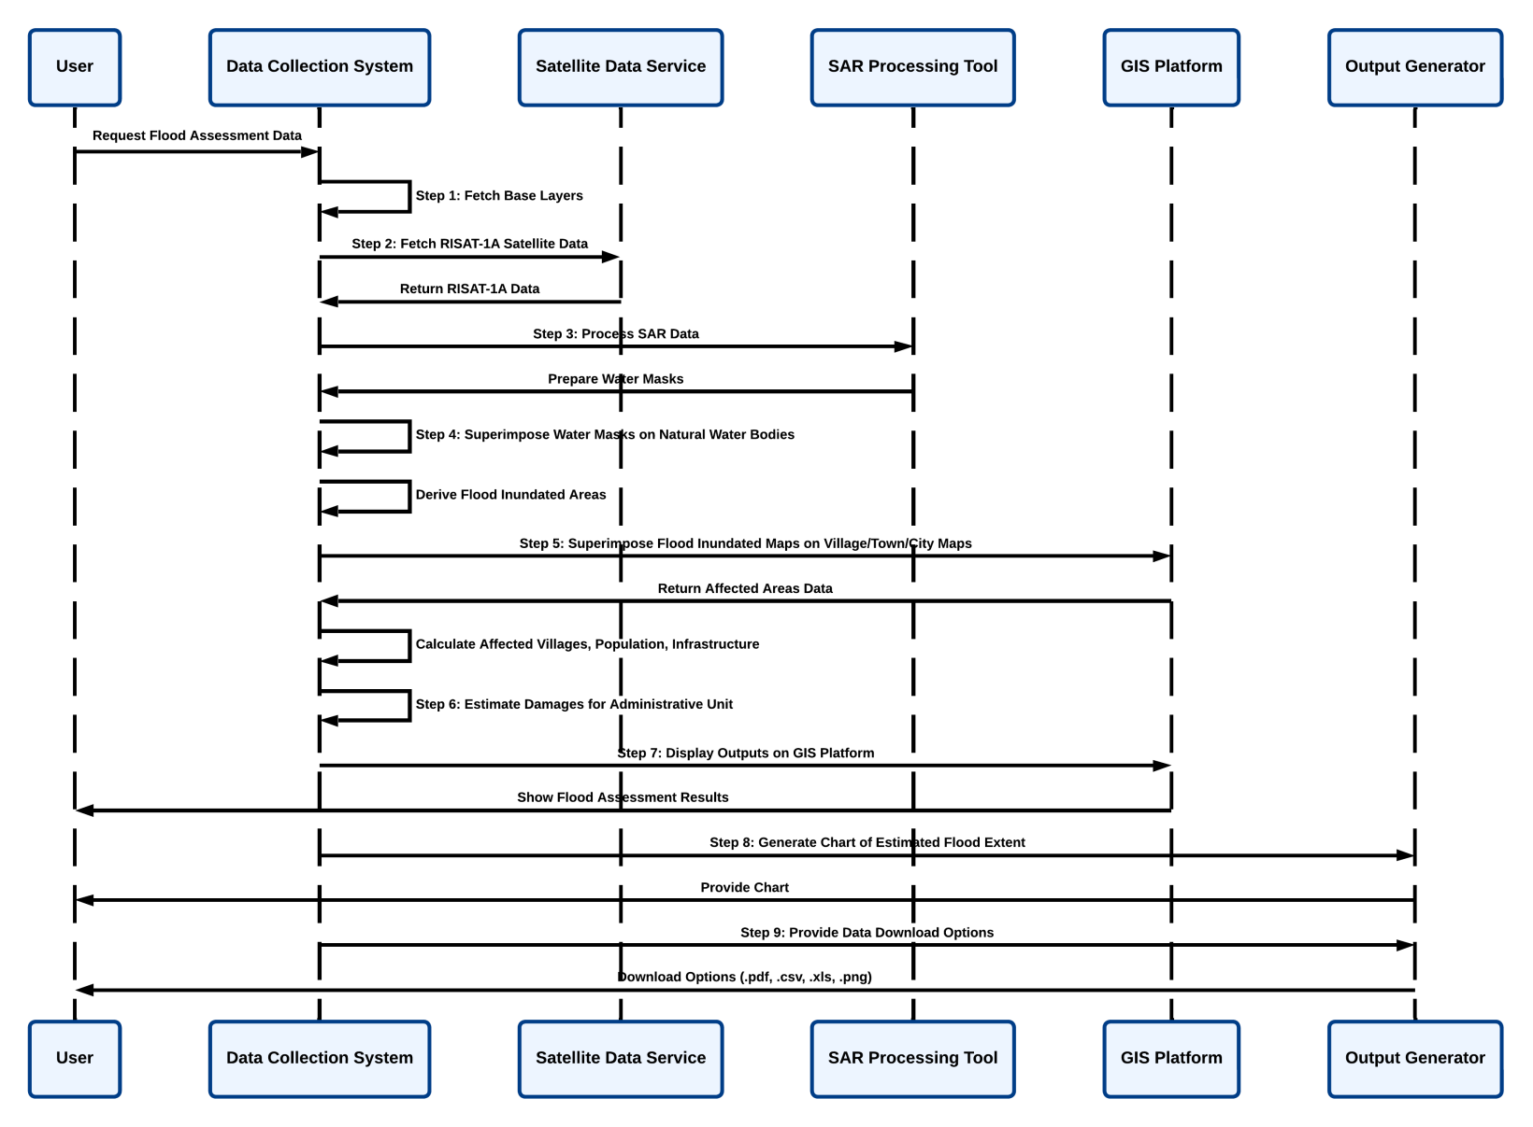**Figure 007_Tools/Step_SequDiag_LucidChart**

**Code For Figure 007_Tools/Step_SequDiag_LucidChart**

@startuml

actor "User " as U

participant "Data Collection System" as DCS

participant "Satellite Data Service" as SDS

participant "SAR Processing Tool" as SPT

participant "GIS Platform" as GIS

participant "Output Generator" as OG

U -> DCS: Request Flood Assessment Data

DCS -> DCS: Step 1: Fetch Base Layers

DCS -> SDS: Step 2: Fetch RISAT-1A Satellite Data

SDS -> DCS: Return RISAT-1A Data

DCS -> SPT: Step 3: Process SAR Data

SPT -> DCS: Prepare Water Masks

DCS -> DCS: Step 4: Superimpose Water Masks on Natural Water Bodies

DCS -> DCS: Derive Flood Inundated Areas

DCS -> GIS: Step 5: Superimpose Flood Inundated Maps on Village/Town/City Maps

GIS -> DCS: Return Affected Areas Data

DCS -> DCS: Calculate Affected Villages, Population, Infrastructure

DCS -> DCS: Step 6: Estimate Damages for Administrative Unit

DCS -> GIS: Step 7: Display Outputs on GIS Platform

GIS -> U: Show Flood Assessment Results

DCS -> OG: Step 8: Generate Chart of Estimated Flood Extent

OG -> U: Provide Chart

DCS -> OG: Step 9: Provide Data Download Options

OG -> U: Download Options (.pdf, .csv, .xls, .png)

@enduml

**Data Validation:-**

**Software Technologies:-**  Python3 and open-source GIS platform or any other

**Dependencies & Risks:** Data availability, permission to fetch data, inability to detect flood depths and distinguishing between & Risks different types of flood etc.

**User Acceptance Testing (UAT):-** CWC, NRSC, SDMA and NDMA

**Development Responsibility:** HARSAC

**References:-**

1. https://ndem nrsc.gov.inflogin.php malarial

2. https:/ibhuvan-appl.nrsc.qov.in/disaster/disaster.php?id=flood

3. https:/ibhoonidhi.nrsc.gov.in/bhoonidhizhome.html

**---End of Document---**